**Leader Overview**

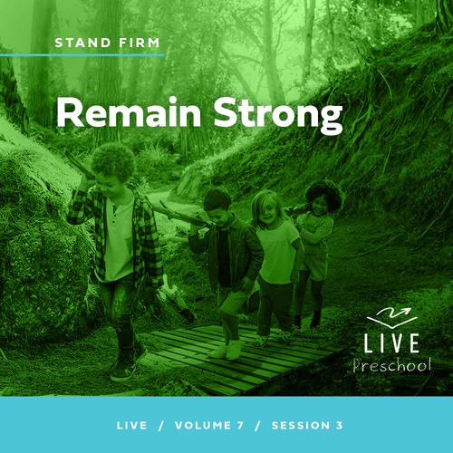

**Volume Overview**

**Stand Firm**

*The world thinks of power as action. Powerful people are able to take control, able to change things. But Jesus blessed the meek, the hungry, and the poor. There is a power this world overlooks. There is power in standing firm in faith. Christians have long stood their ground, not to gain this world’s power but as witnesses to a better world to come. So we stand strong, committed, and bear witness to the world.*

**Session Overview**

**Remain Strong**

*In this* **Live** *session, preschoolers will explore the story of Pilate giving in to the demands of the crowd rather than acting on what he knew was true about Jesus. They will discover that God helps us to be strong and follow Jesus even when others disagree with our decision. This will be a great lesson for preschoolers to learn about God’s strength in the face of opposition.*

**Bible Lesson**

Pilate Gives In to the Crowd and Orders Jesus’ Crucifixion

[Luke 23:1–25](https://ref.ly/logosref/Bible.Lk23.1-25), [44–48](https://ref.ly/logosref/Bible.Lk23.44-48)

**Faith Fact**

I will be strong and follow God.

**Faith Verse**

[Ephesians 6:13](https://ref.ly/logosref/Bible.Eph6.13) (NLT)

Put on every piece of God’s armor so you will be able to resist the enemy in the time of evil. Then after the battle you will still be standing firm.

**Preparing for the Session**

**Leader Preparation Time: 20–25 Minutes**

|  |
| --- |
| ***You Will Need***  ***Preservice Activities***  *• Toys*  *• Small marshmallows*  *• Pretzel sticks*  *• Napkins, one per kid*  ***Large Group***  *• Bible*  *• Worship songs (Song suggestions: “Movin’ Me” Lyric Video by Amber Sky Records; “Living Color” Lyric Video by Elevation Church Kids; “See a Victory” Lyric Video by Elevation Church Kids)*  *• For groups not using a phone or tablet only, add:*  *• Projector or TV*  *• Laptop*  *•* ***Faith Fact Sound*** *video (bell ringing)*  *•* ***Faith Fact Slide***  *•* ***Faith Verse Slide***  *•* ***Faith Verse Video***  *•* ***Bible Lesson Video A***  *•* ***Bible Lesson Video B***  ***Small Group***  *•* ***Small Group Activity Page****, one per kid*  *• Pencils, one per kid*  *• Blindfold*  *• Adult volunteer*  *To access session content and videos from a computer, visit:* [***BibleEngagementProject.com/downloads***](https://bibleengagementproject.com/downloads) |
| ***Getting Ready***  ***Preservice Activities***  *• Set out toys and snacks.*  ***Large Group***  *• Download videos and slides if needed.*  *• Select worship song(s) and have them ready to play.*  ***Small Group***  *• Print copies of the* ***Small Group Activity Page****, one per kid.*  *• Encourage the volunteer to be enthusiastic and a little silly to make the activity fun for the kids. Tell the volunteer to act confused and unable to hear the directions when the kids are singing and clapping.*  ***First time leading* Live *for Preschool? Check out the*** [**Facilitator Guide**](https://0b769b0ed3569ef9d18b-f88d8272f61086866d50d048b43ef630.ssl.cf2.rackcdn.com/sites/biblengagementproject/Listen_Facilitator_Guide.pdf)**.** |

**Preservice Activities**

*See what’s needed at the beginning of the session.*

**Bible Story Warm-Up**

In just a moment, we’ll try something. Your job will be to copy whatever my hands are doing no matter what I’m saying. I may tell you to do something different than I’m doing, so watch my hands closely. Ready? *(Group response)*

• *Go through a series of actions: raise hands, lower them, wave, clap, intertwine fingers, etc.*

• *Do your best to call out actions verbally that are different from what your hands are doing.*

• *For the last few moves, only move your hands and do not talk.*

What was the hardest part of what we just did?

Was it easier for you to follow my hands or my voice?

Was it easier to follow me after I stopped talking?

Sometimes it’s hard to do the right thing even though you know what you’re supposed to do. Like when I was talking, it made it much harder for some of you to follow my hands instead of my words. In today’s Bible story, we’ll learn about someone who knew what the right thing to do was, but he had a hard time choosing to do it because of what other people were saying to him. This will be an exciting day, and I can’t wait to learn more about this with you.

**Snack**

**Barbells (Small Marshmallows and Pretzel Sticks)**

This snack is about getting you pumped up. What do people do when they want to get stronger? *(Allow responses.)* Well, one thing they might do is lift weights. Sometimes they use weights on a barbell. Let’s make a pretend barbell out of pretzel sticks and marshmallows.

• *Give each kid a napkin and two marshmallows and a pretzel stick for each barbell.*

• *Help kids make the barbells.*

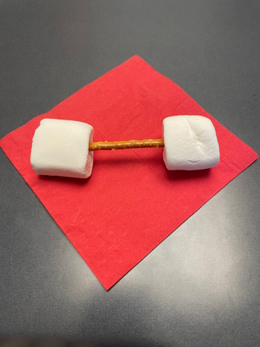

Wow, just looking around I can see all the great barbells you made. We know these won’t help to build real muscles, but it’s fun to think about how strong we could be. Today, we’ll learn how important it is to be strong, but not necessarily in the way that you might be thinking. Having strong muscles is only one way that we can be strong. It’s even more important to be strong and follow God. I can’t wait to learn about this with you.

**Free Play**

*Any extra time can be spent playing with toys.*

**Transition**

*A few minutes before service begins, have kids make their way to the large group area and sit in their designated areas.*

**Large Group**

**25 Minutes**

*See what’s needed at the beginning of the session.*

**Introduction**

Hey, kids! What a great day for us to be here together. I’m always thankful to be here with each of you. On the count of three, look at the friend sitting next to you and say, “I’m glad you’re here.” 1, 2, 3. *(Group response)* That was a beautiful sound as we made everyone here feel welcome. Good job, everyone!

Today, we’ll explore more about God’s Word, the Bible. *(Hold up the Bible.)* Our story is about one of the most important moments in the Bible—when Jesus went to the Cross for our sins. One person in charge, a man named Pilate, knew Jesus had done nothing wrong. The crowd tried to convince Pilate to go against what he knew was right. There will be times that you’ll have to decide whether to make a choice you know is right when other people want you to make a wrong choice.

**Faith Fact**

God is the One who will help us to be strong. Then, we can follow what we know He wants us to do. Our Faith Fact today is **I will be strong and follow God**.

• *Show the* ***Faith Fact Slide.***

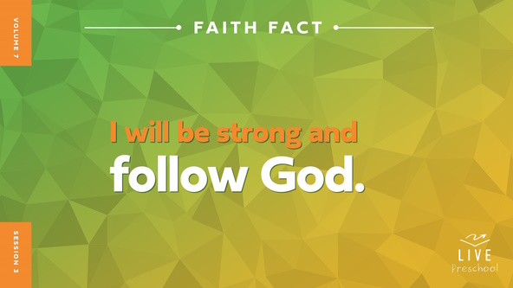

Let’s say our Faith Fact together. The first time we say it yell out the word *strong* and say the rest of the words in a normal voice. **I will be strong and follow God.** *(Group response)* Awesome! This time let’s shout the name of *God* as we say it. **I will be strong and follow God**.

**Bible Time**

God wants to help us grow strong. One of the best ways to do that is to learn from the Bible, God’s Word. *(Hold up the Bible.)* If you think we should see if Lizzy has a Bible story for us, let’s call out, “Lizzy.” *(Group response)* Here she comes!

• *Play* ***Bible Lesson Video A****.*

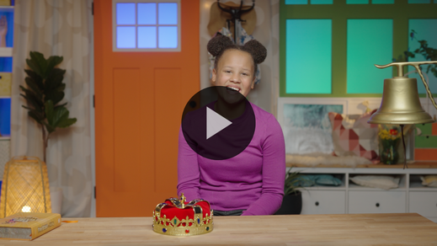

That’s a tough question, isn’t it? Jesus showed us how much He loves us when He walked on the earth, and He continues to show us love every day. Let’s worship Jesus now. Then, we’ll talk about what you think happened next in our Bible story.

**Worship**

Exploring the Bible always reminds me of how big God’s love is. When we worship, we get to focus on God and thank Him for His great love.

**Praise**

Who wants to tell God how great He is? Crouch down low and then jump up as high as you can. *(Group response)*

Are you glad God helps us stay strong? Show me your arm muscles. *(Group response)*

Who wants to thank God that we can trust Him? Clap three times. *(Group response)*

**Sing**

One way we worship God is by singing. Let’s warm up our high singing voices. *(In a high voice, say la-la-la.)* Now, let’s warm up our low singing voices. *(In a low voice, say la-la-la.)* I think we’re ready. Let’s sing!

• *Lead the kids in singing one or two songs. See song suggestions at the beginning of the session.*

**Prayer**

God hears our worship, and He hears our words. Let’s talk to God through prayer.

|  |
| --- |
| *Dear God, You are so good to us. You love us and invite us to follow You. We want to say yes to everything You have for us. Please speak to us through Your Word and help us to draw closer to You. Amen.* |

**Bible Time cont’d**

• *Start* ***Bible Lesson Video B*** *and pause on the image of the two choices.*

Grandpa and Lizzy will be back soon. Let’s put on our thinking caps *(demonstrate).* What do you think happened next in our story? Did Pilate do what he knew was right and let Jesus go? *(Point to “walking man” graphic.)* Or did he give in to the crowd and send Jesus to the cross? *(Point to “cross” graphic.)* Point to the one you think Pilate should have done.

• *Pause while kids respond.*

Let’s find out if that’s what Pilate really did. We need to check back in with Lizzy and Grandpa.

• *Play* ***Bible Lesson Video B.***

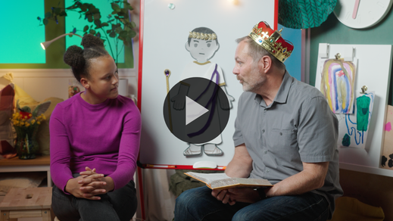

Wow! Pilate thought he was in charge, but Jesus was stronger. Three days after Jesus died on the Cross, He rose again. That means He came back to life. Jesus was stronger than the tomb, and death could not hold Him!

**Response Time**

*Play a worship song quietly.*

Jesus invites us to follow Him. He went to the Cross so that we could receive His forgiveness for all the wrong things we’ve ever done. Jesus wants to wash us clean and make our life and heart as pure as if we’d never sinned or done anything wrong. We just have to accept His gift and follow Him.

• *Have the kids repeat phrases of the prayer after you.*

|  |
| --- |
| *Dear Jesus, I want to say yes to You and Your forgiveness. Please wash me clean from every wrong thing I’ve done. I want to follow You for the rest of my life. Amen.* |

**Faith Verse**

I loved praying that prayer with you. When we ask Jesus to forgive those wrong things we have done, we are following Him. He wants us to stay strong by following God. Let’s stay strong by practicing our Faith Verse together. Today, we’ll work on the entire verse.

[Ephesians 6:13](https://ref.ly/logosref/Bible.Eph6.13) (NLT)

Put on every piece of God’s armor so you will be able to resist the enemy in the time of evil. Then after the battle you will still be standing firm.

• *Show the* ***Faith Verse Video****.*

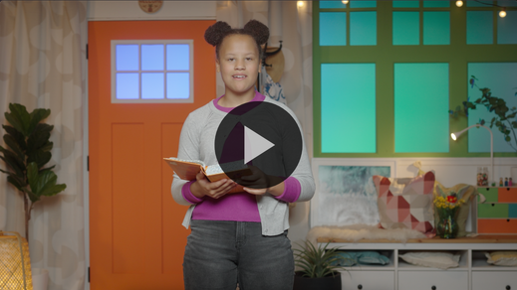

**Ephesians** *(hands at waist, spread apart, palms up and out)*

**6:** *(hands together like a clap)*

**13** *(hands opened to “book”)*

**Put on every piece** *(bring one arm crosswise to pat opposite arm and repeat with other arm)*

**of God’s armor** *(pretend to put on helmet)*

**so you will be able to resist** *(cross forearms together in front)*

**the enemy in the time of evil.** *(put arms out like showing strong biceps)*

**Then after the battle** *(turn around)*

**you will still be standing firm.** *(jump and land with feet together)*

**Closing**

Give me your biggest wave if you enjoyed exploring God’s Word together with me. *(Group response)* I’ll give you my biggest wave *(demonstrate)* because I loved learning our Faith Verse from the Bible with you. I wonder if we have time to say our Faith Fact one more time.

• *Play the* ***Faith Fact Sound*** *video (bell ringing).*

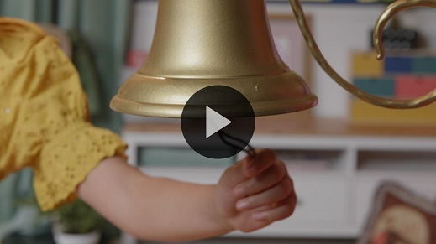

We do! Who remembers it? *(Group response)* Say it with me. **I will be strong and follow God**.

• *Show the* ***Faith Fact Slide.***



Let’s make our strongest muscles as we say it this time. Ready! *(Demonstrate the action.)* **I will be strong and follow God**. Now, let’s march in place like we’re following God while we say it one more time. *(Demonstrate the action.)* **I will be strong and follow God**.

**Dismissal to Small Groups**

Great job! Now, it’s time to go to our circles and have fun with our friends.

• *Dismiss the kids by groups.*

|  |
| --- |
| ***Leader Tip:*** *This can be done by assigning color teams or by age groups. Note that some young preschoolers may not know their age. Using a colored sticker, jersey, or wristband will help separate the kids and help identify their small groups.* |

**Small Group**

**25 Minutes**

*See supplies and prep instructions at beginning of session or in each activity below.*

|  |
| --- |
| ***Leader Tip:*** *Small groups can alternate to each circle, or all groups can do each activity at the same time. If you choose to alternate, you will need at least one leader per circle.* |

**Circle 1**

**Group Connection**

**This or That**

|  |
| --- |
| *No prep needed for this activity.* |

If you’re ready to play a fun game, wave your hand in the air. *(Group response)* When I said that, some of you raised your right hand. Others of you raised your left hand. Did anyone raise two hands? *(Group response)*

I didn’t tell you which hand to raise, so you each had a choice to make. Sometimes the choices we make teach us about ourself and show each other what we believe. Right now, let’s each make some choices. I’ll give you two choices about things you might like. If you like the first thing I say better, you will go to this side of the room. *(Point to one side of the room.)* If you choose the second thing I say, you will go to the other side of the room. *(Point to the other side of the room.)* Got it? (*Group response)*

• *Lead the kids through the list of choices below.*

Here are the choices:

• Cookies or ice cream?

• Music or movies?

• Cats or dogs?

• Playing inside or outside?

• Wearing shoes or going barefoot?

• Candy or cake?

• Singing or dancing?

• Going to the park or swimming pool?

• Playing tag or T-ball?

• Winter or summer?

• Hot dogs or hamburgers?

• Follow God or not follow God?

• *During the activity, interrupt and practice the Faith Fact:* **I will be strong and follow God.**

• *Play the* ***Faith Fact Sound*** *video. Review the Faith Fact even if you can’t play the sound.*



I loved learning about all the things that you like. The choices you made taught me things about you. In our Bible story, we learned that Pilate had a hard time choosing to do the right thing. You and I have a choice to stand up for the right thing and to follow God. With God’s help, we can be strong and follow Him wherever He asks us to go and do whatever He asks us to do.

That reminds me of our Faith Fact. **I will be strong and follow God.** I want everyone to pick out their strongest voice, and together we will say our Faith Fact. Ready? *(Group response)* Let’s do it! **I will be strong and follow God.** Great job!

**Circle 2**

**Activity Page Time**

**Armor or Not?**

|  |
| --- |
| ***You Will Need***  *•* ***Small Group Activity Page****, one per kid*  *• Pencils, one per kid*  ***Getting Ready***  *• Print copies of the* ***Small Group Activity Page****, one per kid.* |

There will be many times that it might seem easier to not make the right choice. But even when it’s hard, we can choose to be strong and follow God. The best part is that God is on our side. He can give us everything we need to be strong.

Our Faith Verse teaches us about one of the ways God has prepared us for these moments. Does anyone remember our Faith Verse? *(Group response)* That’s amazing that you already know it. Learning God’s Word is one of the best ways for us to remember to be strong. Today we’re working on all of the verse. Would you help me learn our verse a little better? *(Group response)* Let’s say it all together.

• *Lead kids in saying the Faith Verse and doing the actions.*

**Ephesians** *(hands at waist, spread apart, palms up and out)*

**6:** *(hands together like a clap)*

**13** *(hands opened to “book”)*

**Put on every piece** *(bring one arm crosswise to pat opposite arm and repeat with other arm)*

**of God’s armor** *(pretend to put on helmet)*

**so you will be able to resist** *(cross forearms together in front)*

**the enemy in the time of evil.** *(put arms out like showing strong biceps)*

**Then after the battle** *(turn around)*

**you will still be standing firm.** *(jump and land with feet together)*

That was awesome! On your Activity Page, there is a soldier who isn’t wearing any of his armor.

• *Hand out a copy of the* ***Small Group Activity Page*** *and a pencil to each kid.*

He really needs your help! Do you think you can find all his armor? *(Group response)* Great! Circle the things that he should be wearing. Then, cross out the things that don’t belong.

• *Give kids time to complete the* ***Small Group Activity Page****.*

I’m so glad this soldier had you to help him! Did you know one of the greatest weapons God gives us is to become strong is learning His Word? Let’s say our Faith Verse together one more time.

[Ephesians 6:13](https://ref.ly/logosref/Bible.Eph6.13) (NLT)

Put on every piece of God’s armor so you will be able to resist the enemy in the time of evil. Then after the battle you will be standing firm.

**Circle 3**

**Feet-to-Floor Game Time**

**Muscle Mania Tag**

|  |
| --- |
| *No prep is needed for this activity.* |

Let me see your best muscle pose. *(Group response)* Whoa! Those are some big muscles. Did you know that God made our bodies strong on purpose? *(Group response)* He can also make us strong on the inside so that we can make the right choices even if crazy things happen.

In our Bible story today, we learned about Pilate who didn’t stay strong on the inside. I want to be strong and follow God. Does anybody else want to be strong and follow God with me? *(Allow responses.)* That’s awesome that so many of you want to do that, too.

During our game, you’ll have a chance to show off just how strong you are. One person will be “It.” When you get tagged, you’ll freeze and show off your muscles. You’ll stay frozen until one of your friends comes by and high-fives you. When they high-five you, you’ll say, “I will be strong.” Then, they’ll finish by saying, “And follow God.”

When you hear me say, “Muscle mania,” everyone will freeze and say our Faith Fact together. Let’s practice it now. **I will be strong and follow God.** After we say it together, everyone will be unfrozen, and I’ll choose a new person to be It. If you’re ready to play, let me hear you say, “Oh, yeah!” (*Group response)*

• *Allow kids to play for as long as time permits.*

**Circle 4**

**Hands-On Learning**

**Follow Strong**

|  |
| --- |
| ***You Will Need***  *• Blindfold*  *• Adult volunteer*  ***Getting Ready***  *• Encourage the volunteer to be enthusiastic and a little silly to make the activity fun for the kids. Tell the volunteer to act confused and unable to hear the directions when the kids are singing and clapping.* |

I need a volunteer for this activity, someone who thinks they’re really good at following directions.

• *Adult volunteer enters enthusiastically.*

Hi! Are you really good at following directions? *(Volunteer agrees.)* Awesome! I need you to put on a blindfold. Okay?

• *Volunteer nods and puts on the blindfold.*

• *Wave your hand in front of the volunteer’s face to demonstrate the person can’t see anything.*

Good. My volunteer can’t see anything. Now, I’ll stand on the other side of the room. I’ll shout out something to make sure they can hear me.

• *Go to the other side of the room. Call out to make sure the volunteer can hear you.*

Great! I want our volunteer to try to follow my directions. They will need to listen to my voice to know where to go. While they’re moving around, I want everyone else to clap your hands and sing loudly.

• *Choose a simple song that all the kids know.*

• *Optional: Sing the song together.*

Do you think you can clap and sing now? *(Group response)*

• *Give the volunteer directions while the kids sing and clap.*

• *Pause when the volunteer is about halfway across the room.*

This is pretty hard with everyone making so much noise. Let me try something different this time. In just a moment, I want everyone to keep clapping and singing the song. But I’ll change one thing. Instead of being on the other side of the room, I’ll go to our volunteer and lead them across the room. Go ahead and make noise again.

• *Lead volunteer to the other side of the room.*

We did it! You can take off your blindfold. Was it harder or easier to make it across the room when I was leading you rather than just talking to you*? (Volunteer responds.)* Yes! Even with all the noise, we were able to make it safely across because I was closer to you.

The same thing is true with us and God. The great thing about following God is that it doesn’t matter how loud other voices are, He’s always right there with us. He will give you and me the strength we need to follow Him wherever He leads. Thanks for helping me today.

**Dismissal**

• *Play the* ***Faith Fact Sound*** *video (bell ringing).*



• *Show the* ***Faith Fact Slide.***



Today has been absolutely awesome! Learning with you is one of the best parts of my day. It’s so much fun to discover God’s plans for us together. Let’s say the Faith Fact together one last time. **I will be strong and follow God.** Great job! I had a great time learning more about God’s Word with you. See you next time!

• *Send home the* ***Small Group Activity Page*** *with each kid.*

• *Remind parents that there are* ***Family Devotions*** *available on the app to do with their kid.*

• *Tell everyone the date and time for the next session.*